MODELS

*Hi! In this Word file, I have included the models I created to complete this project. The models are the block diagram, flow diagram, and the state machine diagram, which was created using the Mealy model.*

**Introduction:**

The ATP is a payment collection system that aims to provide a user-friendly and efficient method for consumers to make payments. It accepts various forms of payment, including cash, cheque, DD, and pay order. The system is equipped with a barcode scanner, which enables automatic activation when the customer places the voucher or bill in the designated slot. The ATP captures data from the voucher/bill, displays relevant parameters on the monitor, and guides the customer through the payment process.

**Objectives:**

The main objectives of this internship project are as follows:

**1**. Design and develop an ATP system capable of collecting payments through multiple modes.

**2 .** Implement a touchscreen and multimedia-based interface for user interaction.

**3 .** Capture data from the voucher/bill and display relevant parameters on the monitor.

**4.** Provide prompts and guidance to the customer during the payment process.

**5** . Implement a secure and efficient payment validation mechanism.

**6** .Generate an acknowledgment for each payment made by the customer.

**MODEL BLOCK DIAGRAM:**

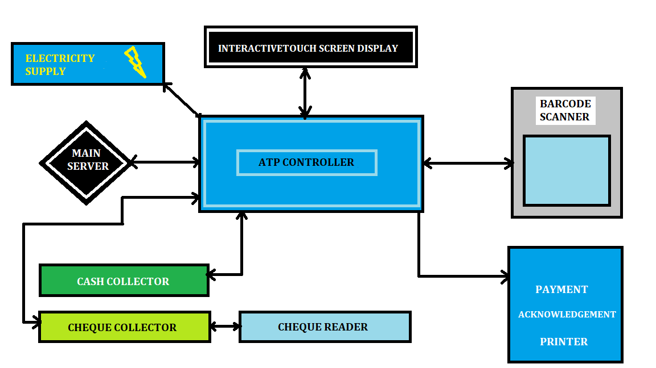

**FLOW DIAGRAM :**

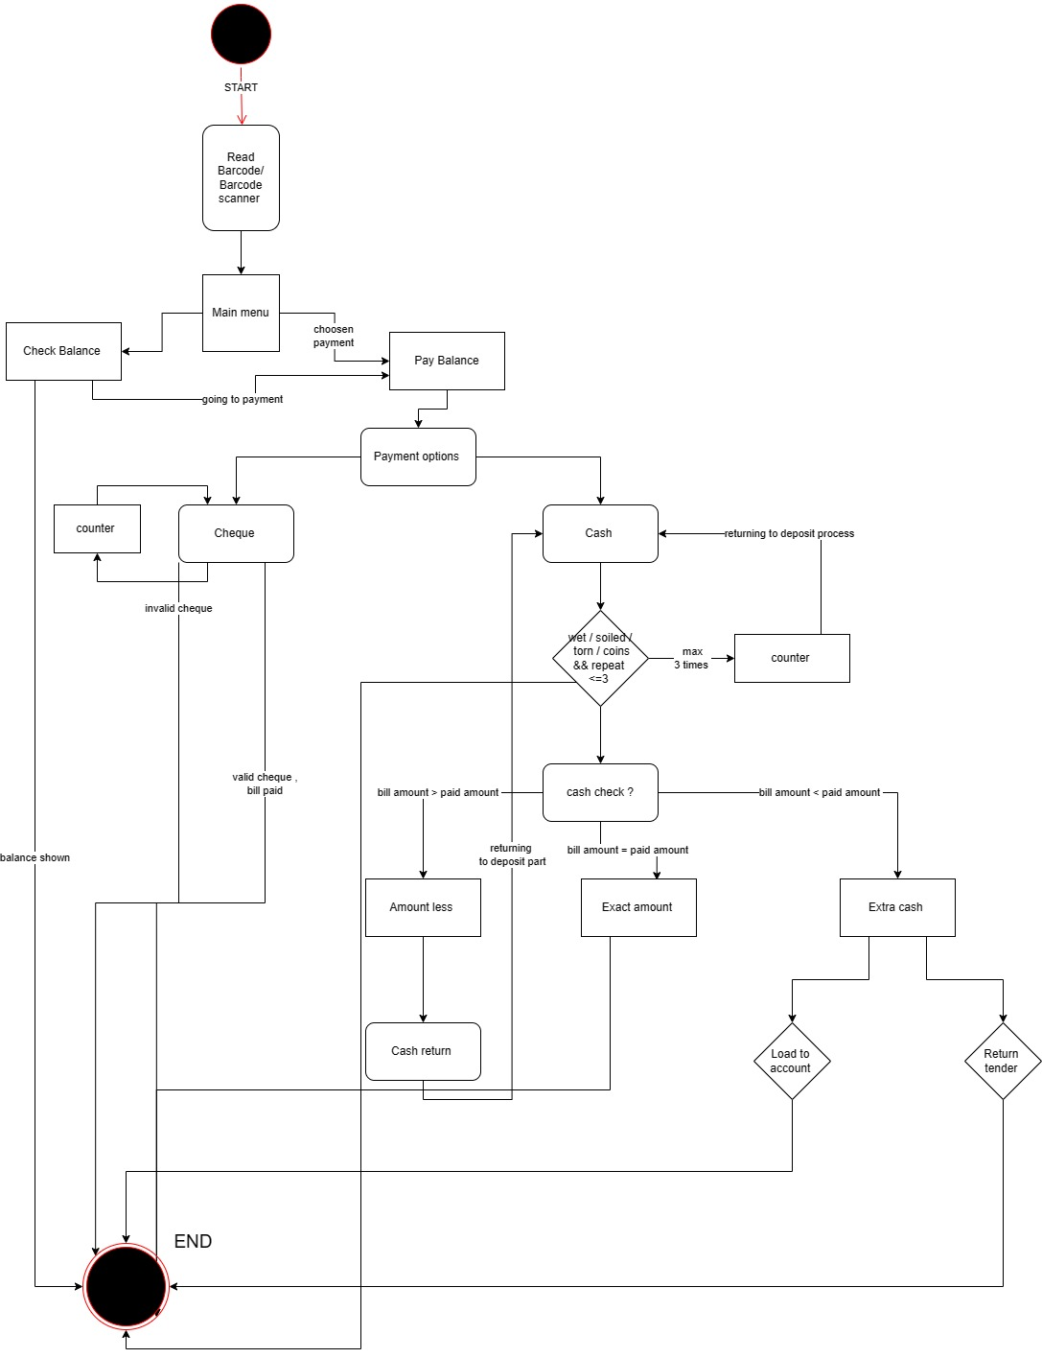

**FSM (Finite State Machine) :**

In a Finite State Machine the circuit’s output is defined in a different set of states i.e. each output is a state. A State Register to hold the state of the machine and a next state logic to decode the next state. An output register defines the output of the machine. In FSM based machines the hardware gets reduced as in this the whole algorithm can be explained in one process.

Two types of State machines are:

MEALY Machine:

In this machine model, the output depends on the present state as well as on the input. The MEALY machine model is shown in this figure .

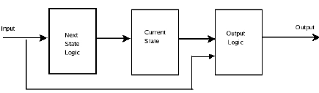

MOORE Machine:

In Moore machine model the output only depends on the present state. The MOORE machine model is shown in this figure

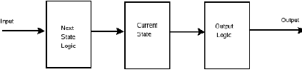

**STATE DIAGRAM:**

(BASED ON MEALY MACHINE)

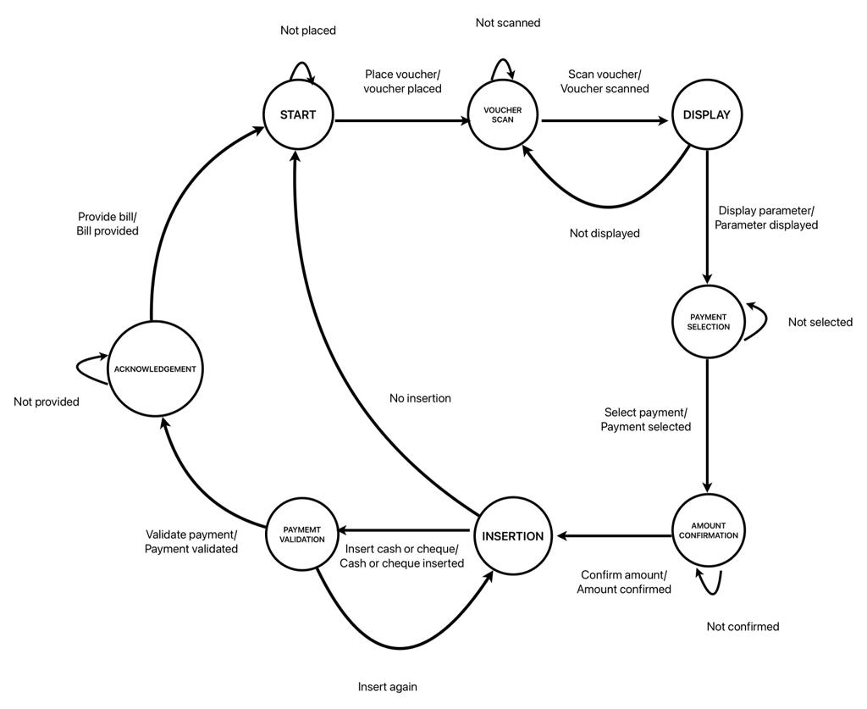

The state diagram is a graphical representation of the different states and transitions within the ATP system. The diagram labels all state transitions and provides a visual representation of the flow of operations during a payment transaction. It illustrates the sequence of actions performed by the ATP in response to user inputs and system events.